**Project Proposal**

For

Clothing Shop Management System

Submitted by

Shehryar Afgan (SP19-BCS-033)

Hasan Ali Raza (SP20-BCS-035)

Department of Computer Science, CU, Islamabad.

5-11-2021

**Table of Contents**

Abstract 2

1. Introduction 3

2. Proposed System 3

3. Advantages/Benefits of Proposed System 3

4. Scope 3

5. Modules 3

5.1 Module 1: Module Name 4

5.2 Module 2: Module Name 4

6. System Limitations/Constraints 4

7. Tools and Technologies 4

8. Conclusion 5

9. References 5

10. Entity Relationship Diagram………………………………………………………………...6

**Project Category:**

* **A-**Desktop Application/Information System

# Abstract

The Clothing Store Management System can help a clothing business or apparel businesses to manage their stocks and sales management. User can login as admin to add new products. Admin can add new products or update existing ones. The system stores the list of products, suppliers. The clothing business can monitor their available stocks in each item or products that they are selling using the clothing store management system and also this system has a feature to manage their transaction with their customer and generate a bill for it.

# Introduction

Instead of going to the store to buy your desired product, this system automates it for your ease and convenience. Now the user can view and purchase their desired product from their home with this user friendly desktop application. Clothing business will also be entertained with an easy interface with which they can manage their products, keep their stock under check and update their products to be made available to the users. This Clothing Store Management System can help a clothing business or apparel businesses to manage their stocks and sales management.

# Proposed System

All the purchase of the customer’s favorite clothing store will be automated making it extremely easy for them to purchase and make transactions of their purchase. Clothing Store Management System will help a clothing business or apparel businesses to manage their stocks and sales management. The clothing business can monitor their available stocks in each item or products that they are selling using the clothing store management system.

# Advantages/Benefits of Proposed System

* Ease in transaction.
* Immediate access of prices, availability, and stock of goods is possible.
* Reduce Inventory Errors.
* Reduce Carrying Costs.
* Improved Planning.

# Scope

In this proposed system, user can login as Admin. Admin have the option to add/delete new products or update existing ones. The system stores the list of products, suppliers. The clothing business can monitor their available stocks in each item or products that they are selling using the clothing store management system and generate/view bill for the customer at the end of his purchase.

# Modules

## Module 1: Login

User can login as Admin or Customer. Upon successful login according to their role they can perform specific tasks such as adding new products as admin or purchasing products as customer.

## Module 2: Products Management

Admin have the option to add/delete new products or update existing ones where as customer has the option to view the products and purchase them as per his/her needs.

## Module 3: Billing/ Transactions

The system will generate bill for the customer at the end of his purchase allowing him to also view it.

## Module 4: Employee management

The system will manage different employee’s information.

## Module 5: Supplier Management

The system stores the list of suppliers and allows the user to manage them.

# DDLScript

CREATE SEQUENCE login_login_id_seq START WITH 1 NOCACHE ORDER;

CREATE TABLE bill (

total INTEGER,

bill_id INTEGER NOT NULL,

method VARCHAR2(256 CHAR),

cashier_id INTEGER NOT NULL,

customer_customerid INTEGER NOT NULL

)

LOGGING;

ALTER TABLE bill ADD CONSTRAINT bill_pk PRIMARY KEY ( bill_id );

CREATE TABLE buys (

customer_customerid INTEGER NOT NULL,

products_product_id INTEGER NOT NULL

)

LOGGING;

ALTER TABLE buys ADD CONSTRAINT buys_pk PRIMARY KEY ( customer_customerid,

products_product_id );

CREATE TABLE cashier (

id INTEGER NOT NULL,

cname VARCHAR2(256 CHAR),

caddress VARCHAR2(256 CHAR),

ccontact_no INTEGER

)

LOGGING;

ALTER TABLE cashier ADD CONSTRAINT cashier_pk PRIMARY KEY ( id );

CREATE TABLE customer (

customerid INTEGER NOT NULL,

cu_name VARCHAR2(256 CHAR),

cu_email VARCHAR2(256 CHAR),

cu_contact INTEGER

)

LOGGING;

ALTER TABLE customer ADD CONSTRAINT customer_pk PRIMARY KEY ( customerid );

CREATE TABLE deals (

employee_id INTEGER NOT NULL,

customer_customerid INTEGER NOT NULL

)

LOGGING;

ALTER TABLE deals ADD CONSTRAINT deals_pk PRIMARY KEY ( employee_id,

customer_customerid );

CREATE TABLE employee (

id INTEGER NOT NULL,

shift VARCHAR2(256 CHAR),

contact_no INTEGER,

login_login_id NUMBER NOT NULL

)

LOGGING;

CREATE UNIQUE INDEX employee__idx ON

employee (

login_login_id

ASC );

ALTER TABLE employee ADD CONSTRAINT employee_pk PRIMARY KEY ( id );

CREATE TABLE login (

email VARCHAR2(256 CHAR),

password VARCHAR2(256 CHAR),

login_id NUMBER NOT NULL

)

LOGGING;

ALTER TABLE login ADD CONSTRAINT login_pk PRIMARY KEY ( login_id );

CREATE TABLE manager (

id INTEGER NOT NULL,

mname VARCHAR2(256 CHAR),

maddress VARCHAR2(256 CHAR),

mcontact_no INTEGER

)

LOGGING;

ALTER TABLE manager ADD CONSTRAINT manager_pk PRIMARY KEY ( id );

CREATE TABLE manages (

manager_id INTEGER NOT NULL,

salesman_id INTEGER NOT NULL

)

LOGGING;

ALTER TABLE manages ADD CONSTRAINT manages_pk PRIMARY KEY ( manager_id,

salesman_id );

CREATE TABLE managesv1 (

manager_id INTEGER NOT NULL,

cashier_id INTEGER NOT NULL

)

LOGGING;

ALTER TABLE managesv1 ADD CONSTRAINT managesv1_pk PRIMARY KEY ( manager_id,

cashier_id );

CREATE TABLE pants (

product_id INTEGER NOT NULL,

pant_color VARCHAR2(256 CHAR),

pant_size INTEGER,

pant_type VARCHAR2(256 CHAR)

)

LOGGING;

ALTER TABLE pants ADD CONSTRAINT pants_pk PRIMARY KEY ( product_id );

CREATE TABLE products (

product_id INTEGER NOT NULL,

product_name VARCHAR2(256 CHAR),

status VARCHAR2(256 CHAR)

)

LOGGING;

ALTER TABLE products ADD CONSTRAINT products_pk PRIMARY KEY ( product_id );

CREATE TABLE salesman (

id INTEGER NOT NULL,

s_name VARCHAR2(256 CHAR),

s_address VARCHAR2(256 CHAR),

scontact_no INTEGER

)

LOGGING;

ALTER TABLE salesman ADD CONSTRAINT salesman_pk PRIMARY KEY ( id );

CREATE TABLE shirts (

product_id INTEGER NOT NULL,

shirt_color VARCHAR2(256 CHAR),

shirt_size INTEGER,

shirt_type VARCHAR2(256 CHAR)

)

LOGGING;

ALTER TABLE shirts ADD CONSTRAINT shirts_pk PRIMARY KEY ( product_id );

CREATE TABLE shoes (

product_id INTEGER NOT NULL,

shoes_color VARCHAR2(256 CHAR),

shoes_size INTEGER,

shoes_type VARCHAR2(256 CHAR)

)

LOGGING;

ALTER TABLE shoes ADD CONSTRAINT shoes_pk PRIMARY KEY ( product_id );

CREATE TABLE supplier (

supplierid INTEGER NOT NULL,

suppliername VARCHAR2(256 CHAR),

description VARCHAR2(256 CHAR)

)

LOGGING;

ALTER TABLE supplier ADD CONSTRAINT supplier_pk PRIMARY KEY ( supplierid );

CREATE TABLE supplies (

supplier_supplierid INTEGER NOT NULL,

products_product_id INTEGER NOT NULL

)

LOGGING;

ALTER TABLE supplies ADD CONSTRAINT supplies_pk PRIMARY KEY ( supplier_supplierid,

products_product_id );

ALTER TABLE bill

ADD CONSTRAINT bill_cashier_fk FOREIGN KEY ( cashier_id )

REFERENCES cashier ( id )

NOT DEFERRABLE;

ALTER TABLE bill

ADD CONSTRAINT bill_customer_fk FOREIGN KEY ( customer_customerid )

REFERENCES customer ( customerid )

NOT DEFERRABLE;

ALTER TABLE buys

ADD CONSTRAINT buys_customer_fk FOREIGN KEY ( customer_customerid )

REFERENCES customer ( customerid )

NOT DEFERRABLE;

ALTER TABLE buys

ADD CONSTRAINT buys_products_fk FOREIGN KEY ( products_product_id )

REFERENCES products ( product_id )

NOT DEFERRABLE;

ALTER TABLE cashier

ADD CONSTRAINT cashier_employee_fk FOREIGN KEY ( id )

REFERENCES employee ( id )

NOT DEFERRABLE;

ALTER TABLE deals

ADD CONSTRAINT deals_customer_fk FOREIGN KEY ( customer_customerid )

REFERENCES customer ( customerid )

NOT DEFERRABLE;

ALTER TABLE deals

ADD CONSTRAINT deals_employee_fk FOREIGN KEY ( employee_id )

REFERENCES employee ( id )

NOT DEFERRABLE;

ALTER TABLE employee

ADD CONSTRAINT employee_login_fk FOREIGN KEY ( login_login_id )

REFERENCES login ( login_id )

NOT DEFERRABLE;

ALTER TABLE manager

ADD CONSTRAINT manager_employee_fk FOREIGN KEY ( id )

REFERENCES employee ( id )

NOT DEFERRABLE;

ALTER TABLE manages

ADD CONSTRAINT manages_manager_fk FOREIGN KEY ( manager_id )

REFERENCES manager ( id )

NOT DEFERRABLE;

ALTER TABLE manages

ADD CONSTRAINT manages_salesman_fk FOREIGN KEY ( salesman_id )

REFERENCES salesman ( id )

NOT DEFERRABLE;

ALTER TABLE managesv1

ADD CONSTRAINT managesv1_cashier_fk FOREIGN KEY ( cashier_id )

REFERENCES cashier ( id )

NOT DEFERRABLE;

ALTER TABLE managesv1

ADD CONSTRAINT managesv1_manager_fk FOREIGN KEY ( manager_id )

REFERENCES manager ( id )

NOT DEFERRABLE;

ALTER TABLE pants

ADD CONSTRAINT pants_products_fk FOREIGN KEY ( product_id )

REFERENCES products ( product_id )

NOT DEFERRABLE;

ALTER TABLE salesman

ADD CONSTRAINT salesman_employee_fk FOREIGN KEY ( id )

REFERENCES employee ( id )

NOT DEFERRABLE;

ALTER TABLE shirts

ADD CONSTRAINT shirts_products_fk FOREIGN KEY ( product_id )

REFERENCES products ( product_id )

NOT DEFERRABLE;

ALTER TABLE shoes

ADD CONSTRAINT shoes_products_fk FOREIGN KEY ( product_id )

REFERENCES products ( product_id )

NOT DEFERRABLE;

ALTER TABLE supplies

ADD CONSTRAINT supplies_products_fk FOREIGN KEY ( products_product_id )

REFERENCES products ( product_id )

NOT DEFERRABLE;

ALTER TABLE supplies

ADD CONSTRAINT supplies_supplier_fk FOREIGN KEY ( supplier_supplierid )

REFERENCES supplier ( supplierid )

NOT DEFERRABLE;

CREATE OR REPLACE TRIGGER login_login_id_trg BEFORE

INSERT ON login

FOR EACH ROW

WHEN ( new.login_id IS NULL )

BEGIN

:new.login_id := login_login_id_seq.nextval;

END;

/

# System Limitations/Constraints

* System available only for desktop users.
* Need a qualified person to manage the system.

# Tools and Technologies

Table 1 Tools and Technologies for Proposed Project

|  |  |  |  |
| --- | --- | --- | --- |
| **Tools**  **And**  **Technologies** | **Tools** | **Version** | **Rationale** |
| Oracle Data Modeler | 2021 | ERD / Scheme Design |
| Oracle SQL Developer | 2021 | DBMS |
| Eclipse | 2020 | Java coding |
| MS Word | 2007 | Documentation |
| **Technology** | **Version** | **Rationale** |
| Java | 6.0 | Programming language |
| SQL | 2021 | Query Language |

# Conclusion

All the purchase of the customer’s favorite clothing store will be automated making it extremely easy for them to manage their daily routine tasks. Clothing Store Management System will help a clothing business or apparel businesses to manage their stocks and sales management, employees, billing, purchases and suppliers.

# Entity Relationship Diagram (ERD)

* **Logical Model:**

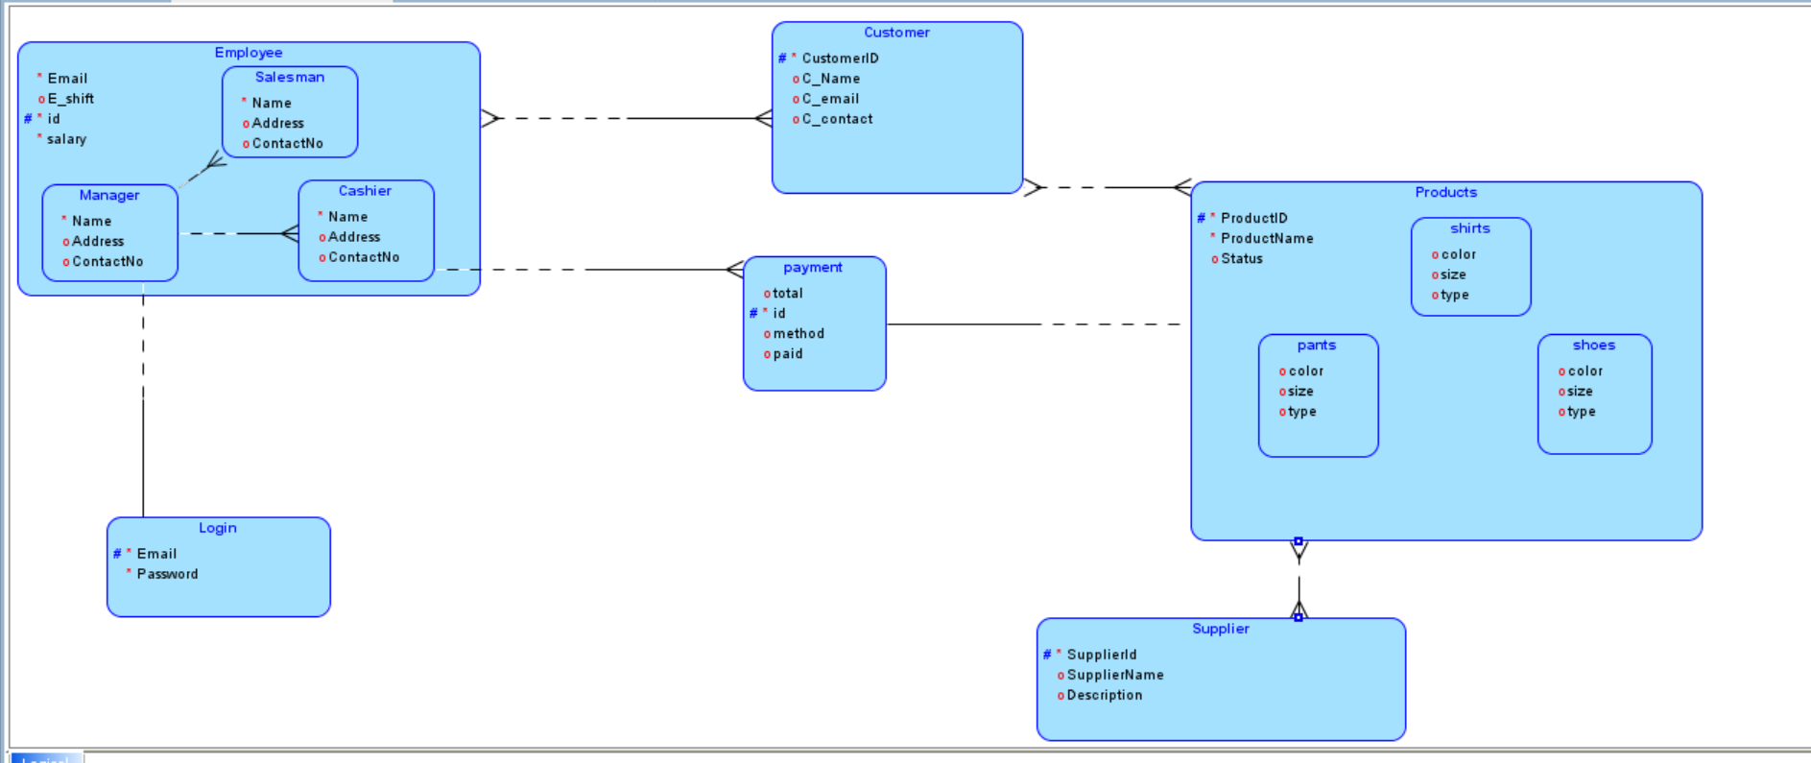

* **Relational Model:**

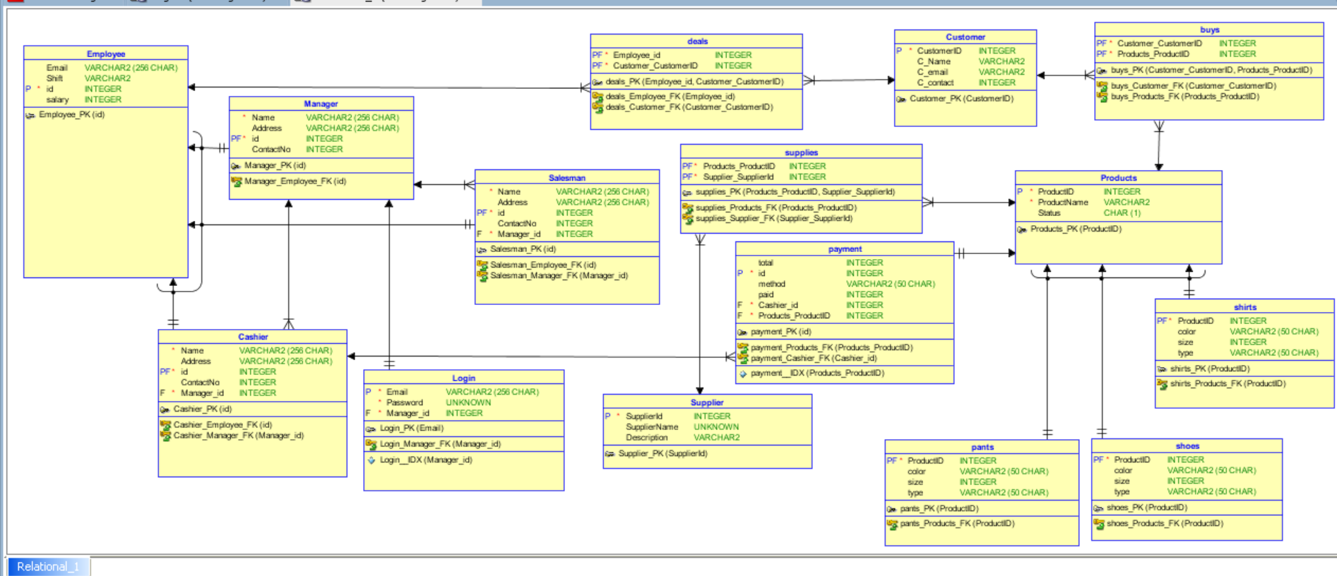

# References

* <https://www.slideshare.net/Ashwini0951/project-report1-189278226>
* <https://www.sourcecodester.com/php/14576/clothing-store-management-system-using-phpmysqli-source-code.html>